**Smart Home**

**Assignment-1**

By

K.Gayathri

952319104012

Smart Home

IOT or internet of things is an upcoming technology that allows us to control hardware devices through the internet. Here we propose to use IOT in order to control home appliances, thus automating modern homes through the internet. This system uses three loads to demonstrate as house lighting and a fan. Our user friendly interface allows a user to easily control these home appliances through the internet. For this system we use an AVR family microcontroller. This microcontroller is interfaced with a wifi modem to get user commands over the internet. Also we have an LCD display to display system status. Relays are used to switch loads. The entire system is powered by a 12 V transformer. After receiving user commands over the internet, microcontroller processes these instructions to operate these

loads accordingly and display the system status on an LCD display.

**Hardware Specifications**

• Atmega Microcontroller

• ESP8266

LCD Display Wifi Module

• DC Cooling Fan

• Relay

• Relay Driver IC

• Vtg Regulator IC

• Resistors

• Capacitors

• Transistors

• Cables and Connectors

• Diodes

• PCB and Breadboards

• LED

• Transformer/Adapter

• Push Buttons

• Switch

• IC

• IC Sockets

**Software Specifications**

• Arduino Compiler

• MC Programming Language: C

• IOTGecko

**IoT devices for securing your home**

• Wall switches

• Voltage Sensors

• Air Conditioner

• Energy Motors

• Smart Door lock

**Circuit Diagram For Smart home**

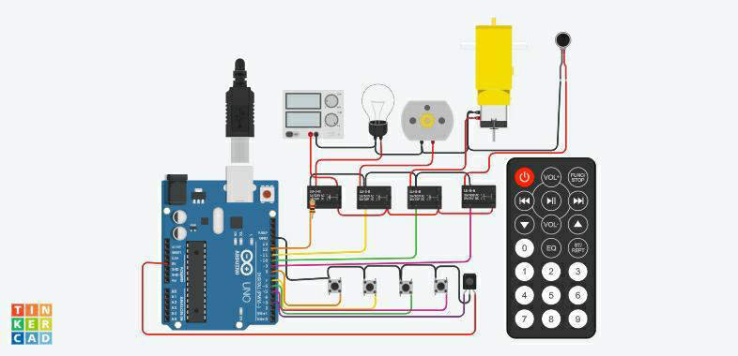

**Coding**

#include <SPI.h>

#include <Wire.h>

#include <IRremote.h>

const int relay_1 = 12; const int relay_2 = 11; const int relay_3 = 10; const int relay_4 = 9;

const int mswitch_1 = 8; const int mswitch_2 = 7; const int mswitch_3 = 6; const int mswitch_4 = 5; int RECV_PIN = 3;

IRrecv irrecv(RECV_PIN); decode_results results;

int toggleState_1 = 0; int toggleState_2 = 0; int toggleState_3 = 0; int toggleState_4 = 0;

void setup() {

Serial.begin(9600); irrecv.enableIRIn();

pinMode(relay_1, OUTPUT); pinMode(relay_2, OUTPUT); pinMode(relay_3, OUTPUT); pinMode(relay_4, OUTPUT);

pinMode(mswitch_1, INPUT_PULLUP); pinMode(mswitch_2, INPUT_PULLUP); pinMode(mswitch_3, INPUT_PULLUP); pinMode(mswitch_4, INPUT_PULLUP);

}

void relayOnOff(int relay){

switch(relay){ case 1:

if(toggleState_1 == 0){ digitalWrite(relay_1, HIGH); // turn on relay 1 toggleState_1 = 1;

}

else{ digitalWrite(relay_1, LOW); // turn off relay 1 toggleState_1 = 0;

} delay(100); break; case 2:

if(toggleState_2 == 0){ digitalWrite(relay_2, HIGH); // turn on relay 2 toggleState_2 = 1;

} else{ digitalWrite(relay_2, LOW); // turn off relay 2 toggleState_2 = 0;

} delay(100); break; case 3:

if(toggleState_3 == 0){ digitalWrite(relay_3, HIGH); // turn on relay 3 toggleState_3 = 1;

}else{ digitalWrite(relay_3, LOW); // turn off relay 3 toggleState_3 = 0;

} delay(100); break; case 4:

if(toggleState_4 == 0){ digitalWrite(relay_4, HIGH); // turn on relay 4 toggleState_4 = 1;

}

else{ digitalWrite(relay_4, LOW); // turn off relay 4

toggleState_4 = 0;

} delay(100); break;

default : break;

}

}

void loop() {

if (digitalRead(mswitch_1) == LOW){

delay(200);

relayOnOff(1);

}

else if (digitalRead(mswitch_2) == LOW){ delay(200); relayOnOff(2);

}

else if (digitalRead(mswitch_3) == LOW){ delay(200); relayOnOff(3);

}

else if (digitalRead(mswitch_4) == LOW){ delay(200); relayOnOff(4);

}

if (irrecv.decode(&results)) { switch(results.value){

case 0xFD08F7: relayOnOff(1); break; case 0xFD8877: relayOnOff(2); break; case 0xFD48B7: relayOnOff(3); break; case 0xFD28D7: relayOnOff(4); break; default : break;

}

irrecv.resume();

}

}